Project 3: Putting it all together

8 models from the semester and how they create an EA framework

Max Moed

5/2/25

Max Moed
Professor Lin
EA 873
5/2/2025
EA 873: Project 3

Introduction:
Modeling is an extremely useful tool and practice for architects, regardless of discipline, to create visuals that are used to illustrate various processes, data flows, and capabilities across organizations. Not only do they create abstract visualizations for architects, developers, and engineers to leverage when building their solutions, they also serve as communication tools for stake holders and project managers to help represent more complex systems and tasks. During this semester, we have learned numerous different models, their techniques and features, and how they can fit into the larger architecture of an organization at the enterprise level. Throughout this paper, I will analyze the pros, cons, and lessons learned from of some of these models, how the models relate to each other, how they relate to processes within my current organization, the standards used for the various models, and how they can be compiled together to help create a wholistic view of The Hershey Company’s digital commerce architecture.

Business Architecture Models
Although most companies begin with an enterprise architecture practice and then add on a business architecture practice later, enterprise architects still employ many business architecture models as foundational blueprints to align business strategy with digital solutions and processes. Business Architecture models allow a company to evaluate key solutions, partners, and goals before designing and delivering a more technology and digitally based business. (Vasudevan & Lowndes, 2024) For this class, we learned how to create four different business architecture based models. The business canvas model, the business model diagram, the business capability model and the business process model. The next section of this paper will review three of these models, the business canvas model, the business model diagram, and the business capacity model.

Figure 1.
Business Canvas Model: The Hershey Company
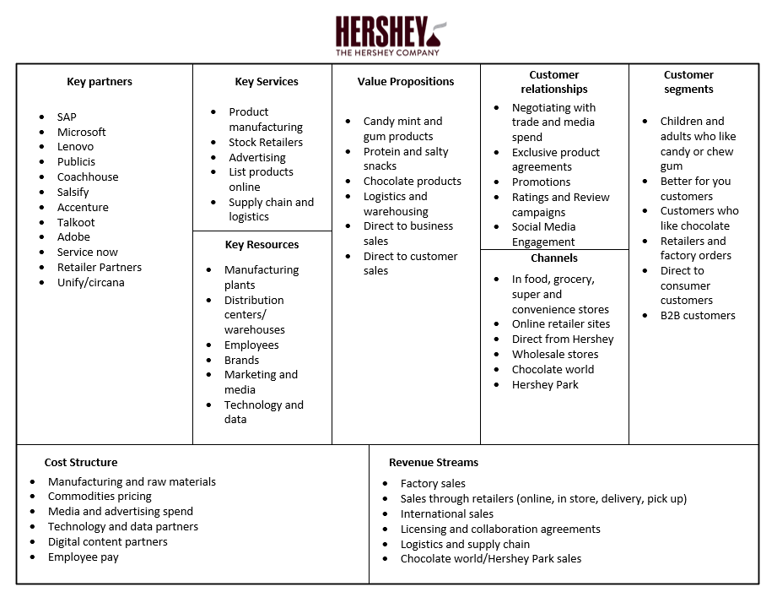
Business Canvas models offer both pros and cons as a modeling technique. The pros are that it is easily readable for both IT and executive/business side stakeholders, it outlines key relationships, value streams and strategies, creates a high-level view of the overall industries in which the Hershey company plays. Also, business canvas models highlight the resources and relationships necessary to compete in the industry. Understanding which resources are required and what goes into transforming them into your specific products goes a long way into understanding the holistic strategy of the entire enterprise. However, aspects that can be considered cons are, there are no processes illustrated or modeled. In addition, there is no flow or sequence to the model just different partitions. Another con is that there are no key or relative metrics that can be measured based off the model. While this model is used more as an abstract communication tool, when doing a canvas model for a new proposition this could be a drawback.
From this model we learned how to create an overview of the partners, relationships, value streams, inputs and outputs of our companies. The model is not currently used at Hershey because we do not have an enterprise architecture practice, but if it were used it would illustrate areas of opportunity based on our in store versus digital performance and potentially new avenues to invest in. This would hypothetically fit into a Hershey EA practice by serving as a key business architecture model that would help stakeholders and IT personnel align business strategy with more complex models and processes.

Figure 2.
Business Model Diagram: The Hershey Company – Digital Commerce
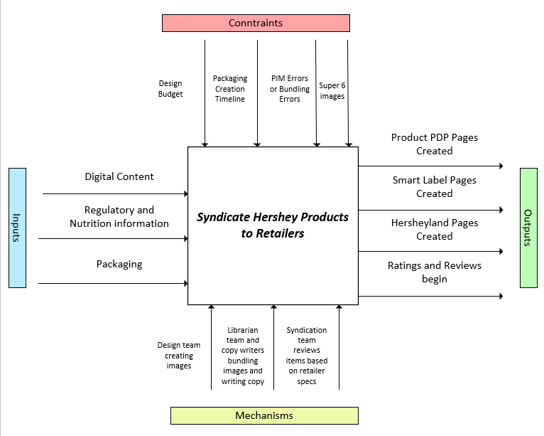
The business model diagram is a tool used to illustrate a high-level movement of processes that create the greater business model of a company or organization within the company. It illustrates the inputs, constraints, mechanisms, and outputs in an organized way that helps provide context to the more technical processes that are required to carry out the business model. The pros of this modeling style are that it creates an easy-to-follow flow of the business model and is adaptable to a whole company or a singular process. In addition, it can help identify process improvement areas and highlights potential barriers in the constraints area. Some cons, however, are that it is very abstract and does not highlight any processes involved in the actual syndication of Hershey products even though that is what the model is based around. In addition, should a model or process require many of any of the four areas the model and arrows can become very cluttered.
From this model, we learned how to better illustrate strategies and processes that drive revenue and growth for a company. Using models to highlight key processes and the factors that go into them is a great way to communicate to stakeholders and executives. This model would fit better with the subsequent models to come rather than the initial model because the scope of the canvas model is broader while the remaining models are more drilled into only the digital commerce organization of Hershey. This model, as well as the following models would fit into the digital commerce architecture framework if the Hershey Company ever adopted that kind of team and practice.

Figure 3.
Business Capability Model - The Hershey Company Digital Commerce.
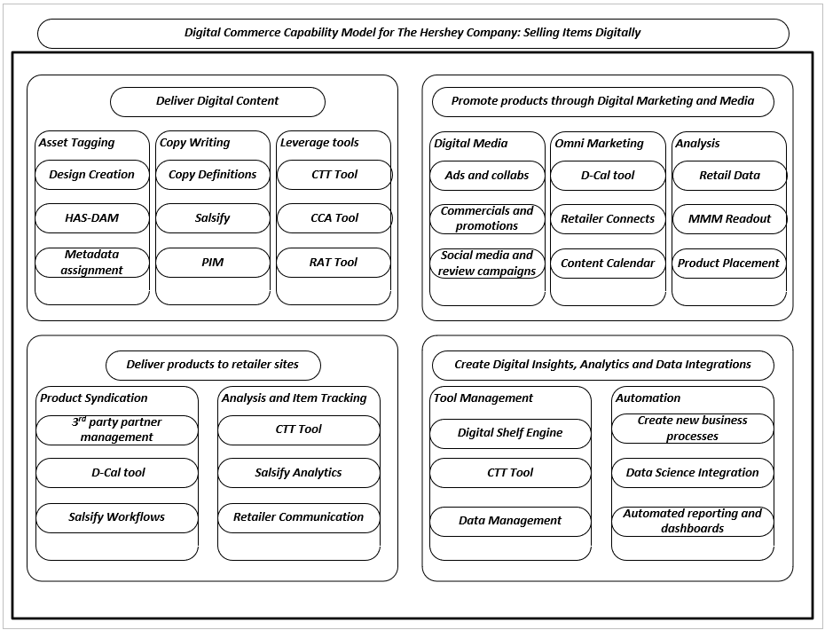
The final business architecture model in this paper is the business capability model. Business capability models consist of multiple layers and smaller capabilities that create a visual of the broader teams, processes and tools that facilitate in carrying out a business capability. The pros for this model are ease of readability, it’s usefulness as a communication and visualization tool, and its adaptability as it can consist of more, or less, layers depending on the need. However, the cons of this model are its toughness to capture the correct scope, no flows are present, and it is very time consuming to create as it involves many different shapes and boxes that need to uniformly fit inside of each other. The lessons we learned from this model are how to distinguish different teams and capabilities within a broader capability or process at an enterprise or organizational level. This model would fit very well alongside the business model diagram as each illustrate various aspects of the digital commerce processes and overall architecture from a business modeling perspective.
These three business architecture models demonstrate various ways in which Enterprise Architecture practices utilize business architecture models to help illustrate business strategies, processes, models, and teams from a business perspective. These models help create clear communication and visuals for stake holders and executives who may not need to see the more complex IT based models that are the part of the broader enterprise modeling practice. Unfortunately, at The Hershey Company, our strategy organization, growth office, and Enterprise data teams are all part of separate organizations and do not collaborate with these types of models and visuals. Standing up an Enterprise Architecture practice in addition to a future business architecture practice could have so many benefits when it comes to aligning goals and strategies to the more complex models and systems that will be presented next in the enterprise architecture model section.

Enterprise Architecture Models
Enterprise Architecture Modeling contains many more model types that include much more detailed and intricate visualizations depending on the type and design. EA models are used to create personas to adhere to user demands, visualize complex data, software, and hardware architectures, and portray deployment of these systems, applications, and data flows so that procedures and system requirements are met. In addition, they are used as schematics or blueprints to help software and application development in various layers to help keep development consistent and in scope.

Figure 4.
Example Persona for a digital content team manager at The Hershey Company.
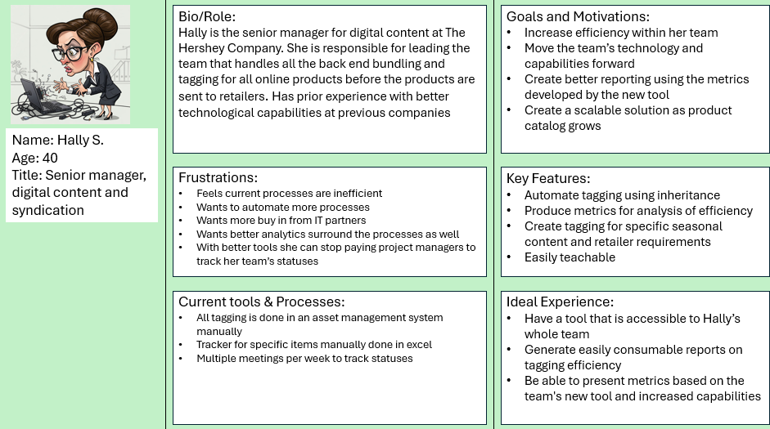
The first enterprise architecture model we learned about is a persona diagram. Personas are useful tools that help users and employees outline their goals, motivations, and ideal experiences. These personas are useful for architects and developers to take these requirements, analyze the current process, and create an ideal experience with key features that will increase efficiency, produce better results, and improve ways of working. The pros of this model are its simplicity, its adaptability, and its ability to prompt cross functional collaboration. From a con’s perspective, it is very simple, the scope is very small since it’s limited to one user or one role, and it has no technical design elements. From an Enterprise Framework perspective, this model does not relate to any of the models that will be included in this paper as it is an example of an ongoing discovery project. However, it would fit in very well with an enterprise level system and process design when stacked with other persona diagrams. This would allow architects to compile different features and requirements from all potential users to develop a solution that would satisfy the users and improve business processes through new technologies.
The lessons we learned from this model is that collaboration with end users and making sure their needs and wanted features are met is an essential step in solution architecture and development. Being able to take business goals and processes and create solutions using feedback from different user groups create better systems, increase efficiency, and create scalable solutions as users use the solutions and provide more feedback to continue future development. In addition, we learned that there are numerous templates and frameworks for creating persona diagrams. While this may seem beneficial it is also extremely important to remember the goal of the model, the specific aspects you are looking for from the end user, and create a visual that is easy for more business centric employees to consume.

Figure 5.

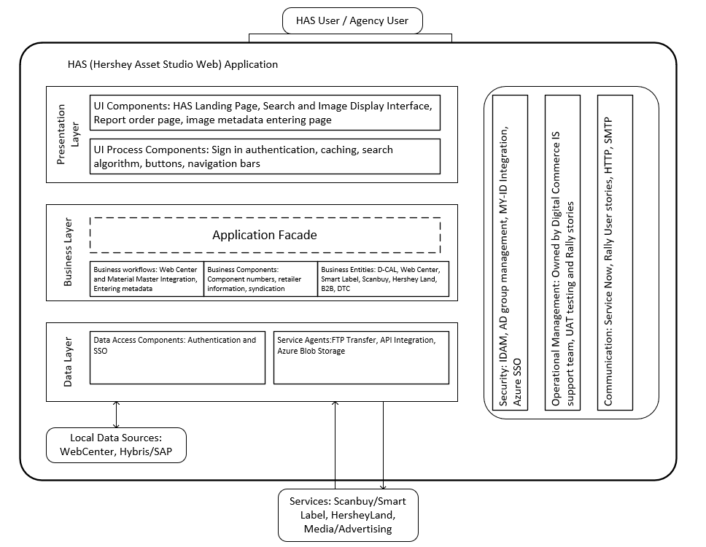
This model is a layered application model that separates software development into three to five distinct layers. The presentation layer, business layer, and data layers each play a key role in application development and help partition off the different aspects of the application development based on the complexity and user base. The pros of this model are its ability to separate more complex processes from user and business processes within the visual, its ability to incorporate communication and governance into the model, and how it shows which services the application will serve. However, layered architecture models also have some shortcomings. First, it requires other more complex models to be stacked with it to provide the entire context of the application and its development. In addition, the models can become verbose if too many layers or components are squeezed into the smaller boxes within the layers. In terms of lessons from this model, it helps with breaking down the process and layers for application development and presents a structured blueprint for attacking the development. This model would fit greatly within the Hershey Digital commerce architecture framework and overall Enterprise Architecture. The Hershey Asset Studio illustrated in this model is the current backbone for the entire online ecosystem from packaging and image creation all the way to online sales on retailer sites and through our B2B business. Since it serves many users and receives support from many teams, the layers in the model can also represent the types of teams and users that all interconnect within the different areas of the HAS which include business side and digital content team users, our IS partners, and the data governance support teams that oversee support teams that handle any back end issues that may occur within the system or during data transfer out of the HAS as well.
The lessons learned from this model is that layered application architecture is a combination of multiple disciplines that are compiled into one to create these models. They require an understanding of data modeling, business architecture models, and business process models. In addition, these models are easily adaptable for mobile device application development, web application development, and software development. Having such a versatile modeling technique creates common structure and communication languages/visuals that are essential to a successful EA practice.

Figure 6.
Use Case Diagram – The Hershey Company B2B Sales Site
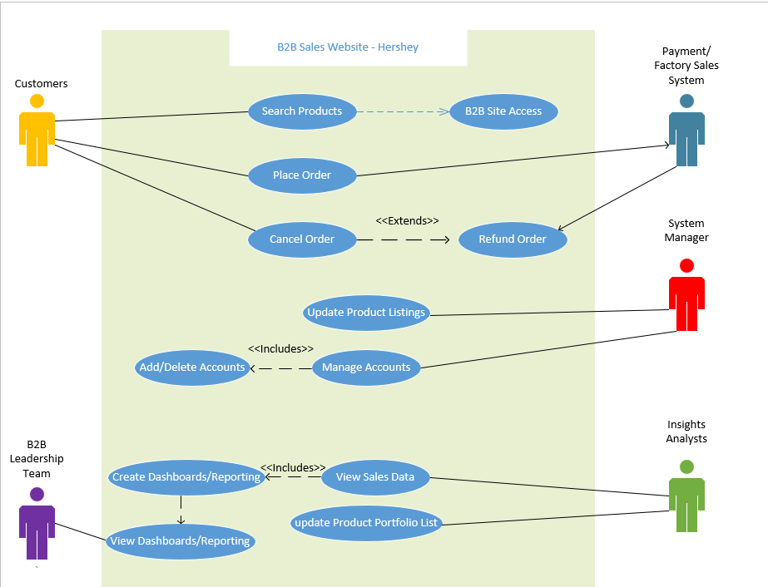
The next model is a use case diagram. These models are used to gather requirements and create representations of processes between users and the technologies that are required to carry out various business transactions. This specific diagram models various actors, both internal and external, who interact with different components to either make purchases on Hershey’s B2B web store or create insights to present to leadership based on the resulting statistics. In terms of how this model fits into the greater potential enterprise architecture framework of the Hershey company, this model would be related to the digital content framework but sit just outside. There are many related processes between B2B and digital commerce, but there are other systems and relationships that would require a separate B2B set of enterprise models and components to be established as part of the broader EA repository.
The pros of use case diagrams are that they can easily identify actors and remove complexity in interactions with various systems. In addition, they can help visualize the flow between customer, the purchasing system, and the back-end technology and processes that support this capability. Moreover, use case diagrams can help in identifying future plans and missing components that would be useful to implement as new features or necessary upgrades. The cons of this model are that they can get quite messy with all the line connections for a complex process. In addition, there are multiple frameworks/notations that can be used to connect the components together which can create some confusions of no enterprise standards are adopted for all use case diagram creation.
In terms of the lessons learned from this modeling exercise, the main goal of this model is to model for requirements. Creating models that can combine actors, processes, basic flows, alternate flows, and special cases into a single visual is great for stakeholder understanding and communication on top of architects understanding technology and process flows. Understanding how users interact with the various systems and processes is paramount to unlocking a growing userbase and achieving the goal of meeting the requirements that the system was modeled to meet.
The final models in this paper will go a step more complex than processes, actors, and business models. These models will illustrate the various dataflows that power the complex processes that are modeled within this section of the paper.

Data Architecture Models

Data Architecture models are a great tool for creating a visual representation of data flows between servers, nodes, systems, and networks. In addition, data models can also illustrate the relationship between data fields themselves and how different data tables relate to each other through various keys.

Figure 7.
ERD Diagram displaying the flow of the D-CAL to Current Priorities Flow – The Hershey Company
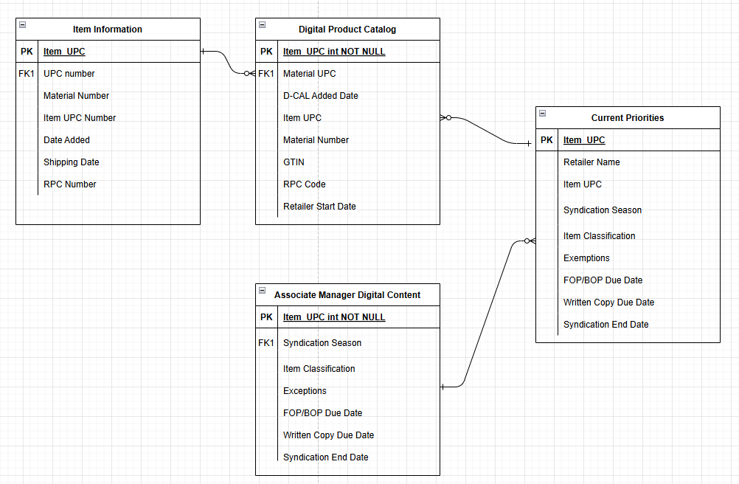
This model is an ERD diagram (Entity Relationship Diagram) which is used to visually represent relationships between data environments and how they connect and interact. In addition, they explain attributes and properties of the data entities and assign uniform associations based on data types within the tables. This specific model, which was created using draw.io, illustrates the flow and relationship between four different data locations within the Hershey data ecosystem. The systems send data to a database called the current priorities database which feeds the workflow tool that creates the tracking logic and dashboards for the digital content process within Hershey. This model fits into the broader Enterprise Architecture of the Hershey digital commerce framework because it illustrates the data flows necessary to carry out the processes modeled in earlier sections. Without these data flows, there would be no content syndication to retailers and to our B2B site, which means no sales.
The pros of this model are its readability, its scalability based on how many data tables and relationships are necessary, its illustration of the primary and foreign keys which show data structures. In addition, these models can show different levels of complexity from the conceptual level to the logical level, and the physical level. Having a modeling standard that is versatile and scalable creates multiple uses allowing for standardized data notation and modeling throughout the enterprise.
There are also cons to ERD diagrams, however. First, there are multiple notations to choose from, each having their own sets of pros and cons. Second, these notations use different arrow types to represent cardinality which creates the need for specific modeling templates or the need to download specific software/visit specific web apps to model them. Lastly, on their own these models don’t illustrate the systems and software they necessarily feed into or what the intended purpose outside of the data relationships are.
From a learning perspective, this model introduced us to the concept of data modeling. Data modeling is one of the more complex methods of modeling as it can create extremely complex models depending on the level of detail and layers involved. Specifically for ERD diagrams, we learned about various notation styles and how each one represents relationships and cardinality. From an EA perspective this taught us how each layer of architecture, from business, to software, to processes and governance, and lastly to data, all require collaboration and an understanding of relationships and requirements.
The final model in this paper, is this same model, but done by Plant UML code, instead of a modeling software where you create the visuals by keyboard and mouse with objects.

Figure 8.
ERD Diagram created using PlantUML code– The Hershey Company
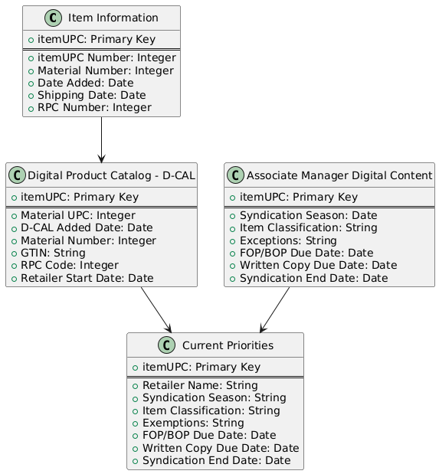
This final model is a PlantUML code created version of the ERD diagram from above. PlantUML diagrams are created by writing code instead of creating the objects and doing the formatting by mouse and keyboard. There are multiple types of UML models, and this one is a class model that creates the same visual as the ERD model. This modeling style can play a huge role in future Enterprise Architecture practices. It can standardize notation and modeling practices by requiring all modelers to use the same tools and code to create the models within the EA repository. While not every model is currently supported, as technology and AI improves more model types should be added in the future.
The pros of this model, and PlantUML in general is the efficiency in which the models can be created. The time savings and structuring of the code is extremely user friendly and as you become more acclimated to the coding language the more customization is possible. In addition, the formatting and connections are all done within the code which makes the notation and choosing of the corresponding arrows easier. Lastly, the final pro is that the sharing of code through a txt file or similar is much smaller of a file than a complete model created in a modeling tool. Using the PlantUML rendering server or other tools to render the code makes it much easier to share without sharing the complete model.
The cons of this model and PlantUML in general is the learning curve. There are multiple model types each having similar but not the same syntax and learning all the notations and customizations can take time. In addition, AI can create the code or render the models based on descriptions or modify existing code which could create efficiency but create people redundancy leading to potential role elimination.
This modeling lesson taught valuable information about the potential future of modeling as a discipline within Enterprise Architecture as a practice. Being able to code complex models could lead to incredible efficiency if a few selected standards become the norm within the space. In addition, it can open new job opportunities for UML and other model code language experts and allow for cleaner models to be created with AI using existing models in the future. Modeling through code is something I would like to continue building on in the future and without this lesson, I would not have been exposed to it.

Conclusion:
Having presented eight of the twelve models from this semester, based on the explanations, pros and cons, and learnings, it is prevalent that The Hershey Company would greatly benefit from standing up an EA practice and adopting EA frameworks, techniques and models. Creating a digital commerce enterprise framework where documents, models, processes, and roadmaps can be shared for communication with stakeholders, and updated based on current strategy and needs would be a big steppingstone for us as a company.
From the business architecture models, we learned how to abstractly convey various processes that help serve both the broader strategy as well as the digital commerce strategies. From the EA models, we understand the users and stakeholders and the more technical processes that go into systems like our B2B store and our Hershey Asset Studio. Lastly, from the data architecture models, we not only learned how data flows from various systems to help our content teams complete tasks, but of emerging trends that could increase model production in the future should we decide to embark on this architecture journey.
This course has taught us so much about models, how they are created, why they are used, and why they are so valuable for preparation and planning. Using these eight models, I hope I have helped paint a picture of the digital commerce strategy, some of the capabilities that help achieve our strategies, and the data flows that these capabilities rely on. My goal is to take some of these example models, the learnings from this course, and the learnings from this program overall, to help pitch the idea of adopting more modeling techniques and frameworks in the future.

References:
Vasudevan, A., & Lowndes, M. (2024, November 21). Align Digital Commerce
Architecture with Business Outcomes. gartner.com. https://www.gartner.com/document/5940107?ref=solrAll&refval=453982964&

